SHAHEED ZULFIQAR ALI BHUTTO INSTITUTE OF SCIENCE AND TECHNOLOGY
Bachelor of Science in Artificial Intelligence
Department of Artificial Intelligence

Computer Networks • CSCL3209 • 4th Semester

Design and Implementation of a
Static NAT Configuration
Using Cisco Packet Tracer

Course | Computer Networks (CSCL3209)
Program | Bachelor of Science in Artificial Intelligence
Semester | 4th Semester (2nd Year)
University | SZABIST
Instructor | Engr. Unzela Talpur
Submission Date | 8, April 2025

Team Members
# | Name | Roll Number
1 | Anzal Azam Shaikh | 24108106
2 | Nadia Shaikh | 24108120
3 | Muhammad Mustafa | 24108118

Table Of Contents

1. Performance Objective 3
2. Requirements 3
Software 3
Hardware (Simulated) 3
3. Introduction 4
2.1 Overview of the Topic 4
2.2 Key Concepts and Background 4
2.3 Importance and Scope 5
3. Methodology (Implementation Steps) 5
3.1 Project Description 5
3.2 IP Addressing Scheme............................................................................................5
3.3 Step-by-Step Implementation .................................................................................5
3.4 Cisco IOS Configuration...........................................................................................5
5
3.2 IP Addressing Scheme 5
3.3 Step-by-Step Implementation 6
3.4 Cisco IOS Configuration Commands 6
4. Results and Discussion 7
4.1 Simulation Screenshots 7
4.2 Results Analysis 16
4.3 Challenges Faced and Solutions 17
5. Conclusion 17
5.1 Summary of Work 17
5.2 What We Learned 18
5.3 Effectiveness of Implementation 18
5.4 Future Improvements 18

Performance Objective
After finishing this project students will know how to:

- Say what results they can expect from the project idea they picked.
- Show how networking concepts work using a simulation tool called Cisco Packet Tracer.
- Set up Static NAT on a Cisco router so outside computers can reach servers.
- Check NAT. Fix common problems, with network connections.

Requirements

Software
- Cisco Packet Tracer

Hardware (Simulated)
- Two(2) Routers-PT (Router1 - NAT Router, Router2 - ISP Router)
- Two(2) Switch 2960-24TT (Switch1 - LAN side, Switch2 - WAN side)
- Seven(7) PCS-PT (PC0, PC1, PC2 on LAN; PC3, PC4 on WAN; Server1)
Two(2)Laptop-PT (Laptop0 on LAN, Laptop1 on WAN)

Introduction

2.1 Over view of the Topic

In computer networks managing IP addresses can be tough. The internet has grown much that it's hard to find IPv4 addresses now. To solve this Network Address Translation or NAT was introduced. NAT helps devices on a network share one or a few public IP addresses when they talk to the outside world.This project is about Static NAT. It's a way of doing NAT. Here each private IP address is always mapped to one IP address.

The project uses Cisco Packet Tracer to simulate the process. Cisco Packet Tracer is a tool, from Cisco Systems that helps simulate networks.

2.2 Key Concepts and Background
- To work on this project you need to know some networking concepts.
- These networking concepts are important for understanding and implementing this project.
- Here are the key networking concepts:
- IP Addressing: Every device on a network needs an IP address.
- IP addresses are like numbers that're 32 bits long.
- These IP addresses are usually divided into two groups: public IP addresses and private IP addresses.
- Private IP addresses, like 192.168.x.x cannot be used on the internet.
- Network Address Translation: This is a way for a router to change the address information in packets as they move through the network.
- Network Address Translation helps devices on a private network talk to devices on a network.
- This is really useful because it lets devices on a network communicate with devices on a public network using Network Address Translation.
- Static Network Address Translation: This is when a private IP address is always connected to an IP address.
- This connection has to be set up for Static Network Address Translation.
- It is usually used for servers that need to be reached from the internet using the IP address and Static Network Address Translation.
- Router Configuration: For Cisco routers you need to configure the interfaces with IP addresses.
- You also need to say which interfaces are on the side and which are on the public side for Router Configuration.
- This is necessary for Network Address Translation to work correctly with Router Configuration.
- Default Gateway: Every device needs to be set up with a default gateway.
- This is usually the IP address of the routers interface on the network for the default gateway.
- The default gateway helps devices send traffic outside of their network using the default gateway.
- Cisco IOS Commands: The command line interface for Ciscos operating system is used to set up all the router settings.
- This includes IP addressing and Network Address Translation rules using Cisco IOS Commands.
- The Cisco Internetwork Operating System command-line interface is really important, for configuring all the router settings using Cisco IOS Commands and the Cisco Internetwork Operating System.

2.3 Importance and Scope
Static NAT is very important for companies and data centers. This is because internal servers, such as web servers, mail servers and database servers need to be accessible from the internet. They need an IP address. The goal of this project is to design a network.
It will have two routers. One will have a subnet and the other a public subnet. We will set up Static NAT on the router, which is Router 1.The goal is to let a computer on the network, PC1 communicate with a computer, on the public network, PC0. We will use IP addresses for the gateways.
For example Router 1s network interface will use 192.168.1.1.
The public interface of Router 1 will use 200.0.0.1.

3. Methodology (Implementation Steps)

3.1 Project Description
In this project the network setup is such that a company has its internal private network with the address 192.168.1.0/24. This internal private network is connected to a network outside through a special router called a border router. The people who know about this say that setting up Static NAT on the border router helps to change a computers IP address to a public IP address when it needs to share information with the outside world. This way the area where the public IP address works is safe. It is easy for the private and public networks to talk to each other.
Two routers are connected to each other using a kind of link called a serial or FastEthernet WAN link to make this network setup. Computers are attached to the local network part of each router so that they can show the public sides. People have seen that this network setup helps to keep the connection stable. The network topology is very important here. It helps to make sure that the private network and the public network can work together smoothly. The network topology is the key, to making this work. It is used to connect the private network and the public network.

3.2 IP Addressing Scheme
The following IP addressing plan was used in the simulation:

Device | IP Address | Gateway | Network Type
PC1 (Private Host) | 192.168.1.x | 192.168.1.1 | Private LAN
Router 1 – LAN (Fa0/0) | 192.168.1.1 | — | Inside Interface
Router 1 – WAN (Fa0/1) | 200.0.0.x | — | Outside Interface
Router 2 – LAN | 200.0.0.1 | — | Public Network
PC0 (Public Host) | 200.0.0.x | 200.0.0.1 | Public Network

3.3 Step-by-Step Implementation
To set up the Static NAT configuration in Cisco Packet Tracer I did the following steps:
- I opened Cisco Packet Tracer. Created a new project. Then I. Placed two routers, like the Cisco 2811 and two PCs on the workspace.
- I connected PC1 to Router 1s FastEthernet0/0 which's the LAN or inside interface using a regular copper straight-through cable.
- Next I connected Router 1s FastEthernet1/0 which's the WAN or outside interface to Router 2s FastEthernet1/0 using a copper crossover cable.
- After that I connected PC0 to Router 2s FastEthernet0/1 using another copper through cable.
- I configured PC1 with an IP address for example 192.168.1.2/24 and I set the default gateway to 192.168.1.1, which is Router 1s LAN interface.
- Then I configured PC0 with an IP address in the 200.0.0.0/24 range and I set its default gateway to Router 2s LAN interface IP.
- I configured Router 1 by accessing the command line interface. I assigned 192.168.1.1/24 to Fa0/0. I assigned a public IP, like 200.0.0.2/24 to Fa0/1. I enabled both interfaces with the 'no shutdown' command.
- I configured Router 2 by assigning an IP to its WAN interface, which is connected to Router 1 and I set a gateway IP for the public PC. I enabled all interfaces on Router 2.
- On Router 1 I defined the Static NAT mapping using the command: ip nat inside source static. I specified the private IP and the public IP.
- I marked the NAT interface on Router 1 which is Fa0/0 using the command: ip nat inside.
- I marked the NAT interface on Router 1 which is Fa0/1 using the command: ip nat outside.
- I added a default route on Router 1 that points to Router 2s WAN interface using the command: ip route 0.0.0.0 0.0.0.0. I specified the next-hop IP.
- I added a return route on Router 2 if it was needed. I pointed the public IP range back to Router 1.
- Finally I tested the connectivity by sending a ping from PC1, which's the private PC to PC0, which is the public PC. The Static NAT configuration should translate the IP addresses automatically.
- I checked the Static NAT translation table using the commands: show ip nat translations and show ip nat statistics, on Router 1 to see how the Static NAT configuration is working.

3.4 Cisco IOS Configuration Commands
Key configuration commands used on Router 1:

IOS Command | Purpose
interface fa0/0 | Enter interface Fa0/0 configuration mode
ip address 192.168.1.1 255.255.255.0 | Assign private IP to inside interface
ip nat inside | Designate as inside NAT interface
no shutdown | Enable the interface
interface fa0/1 | Enter interface Fa0/1 configuration mode
ip address 200.0.0.2 255.255.255.0 | Assign public IP to outside interface
ip nat outside | Designate as outside NAT interface
no shutdown | Enable the interface
ip nat inside source static 192.168.1.2 200.0.0.2 | Define Static NAT mapping
ip route 0.0.0.0 0.0.0.0 200.0.0.1 | Set default route to public gateway
show ip nat translations | Verify active NAT translation entries
show ip nat statistics | Display NAT hit/miss statistics

4. Results and Discussion

4.1 Simulation Screenshots
Here are the screenshots from the Cisco Packet Tracer simulation. These are to show you how to do a Static NAT configuration and to verify that it works.
We will go through each screenshot one, by one. Explain what is happening in each one of the Cisco Packet Tracer screenshots.

Screenshot 1 – Network Topology Overview
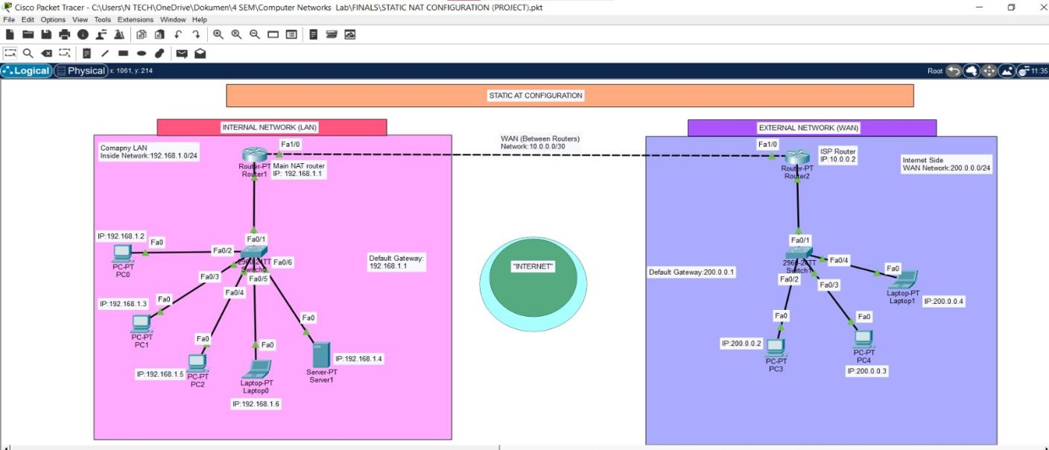

Figure 1: Complete network topology in Cisco Packet Tracer showing Router 1, Router 2, PC1 (private), and PC0 (public) with all connections.

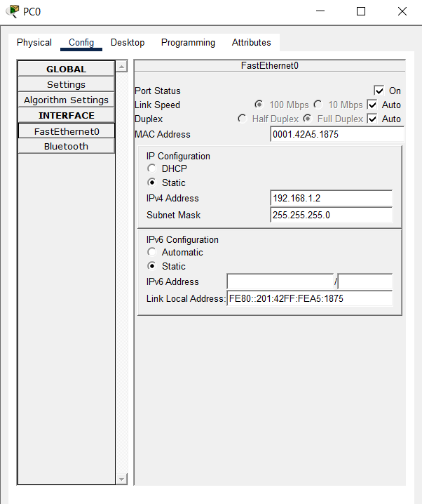
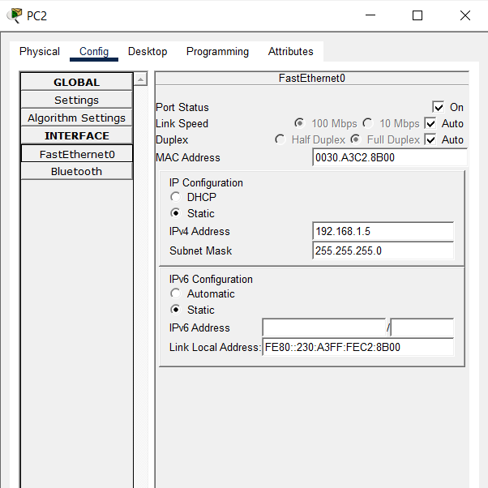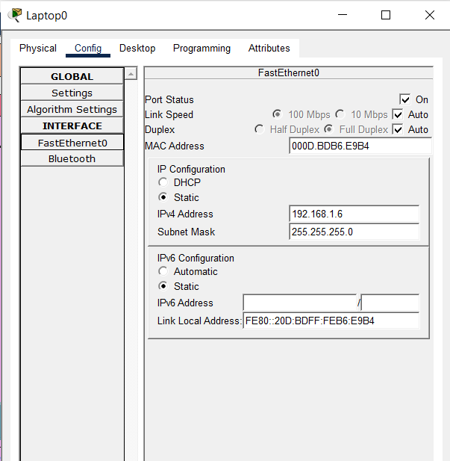
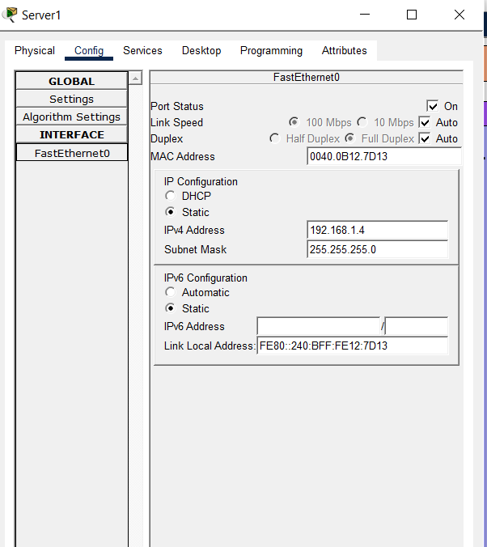
Figure 2 IP Addresses given to the devices which are connected to Switch 0 to Router1

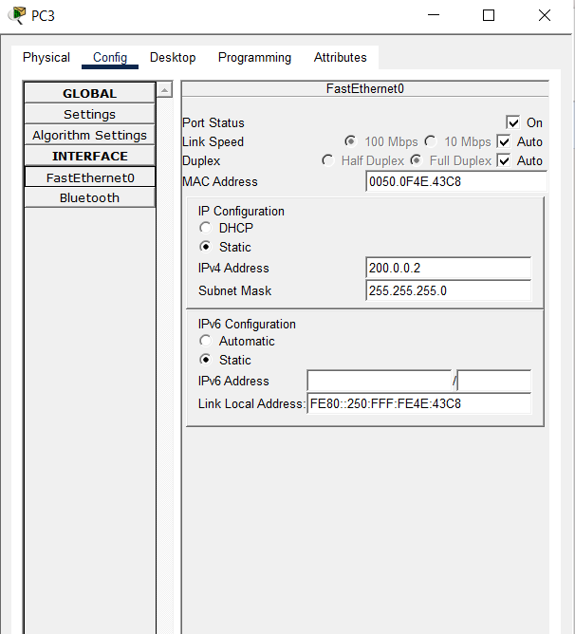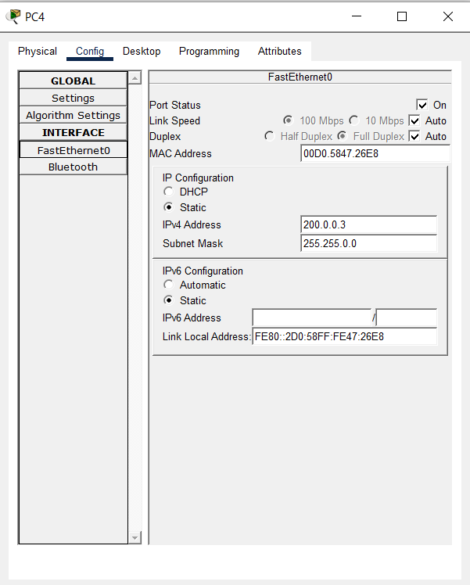
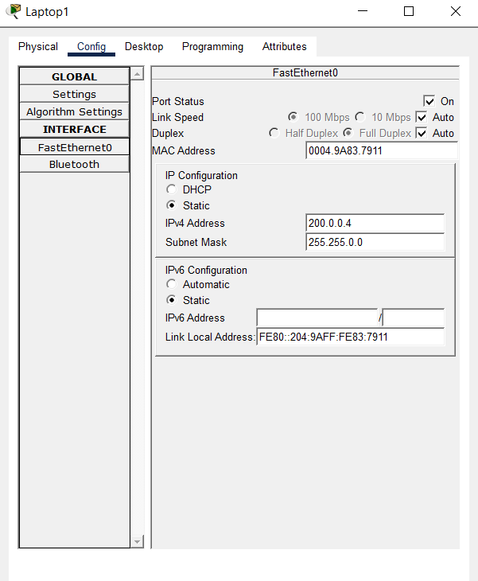
Figure 3 IP Addresses given to the devices which are connected to Switch 1 to Router2

Router1 Interfaces Configurations

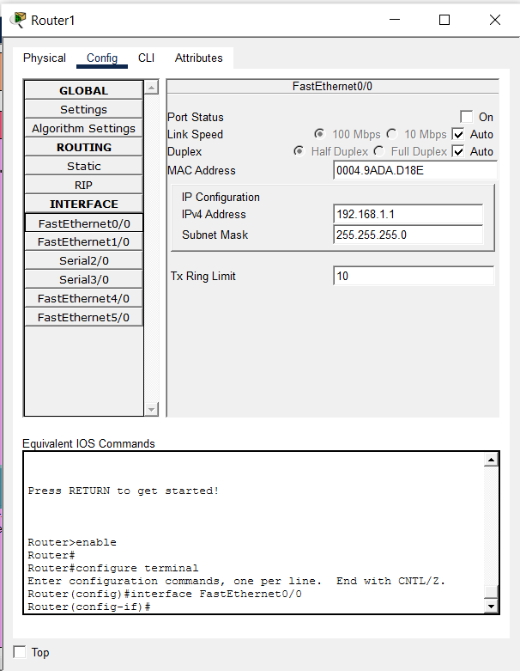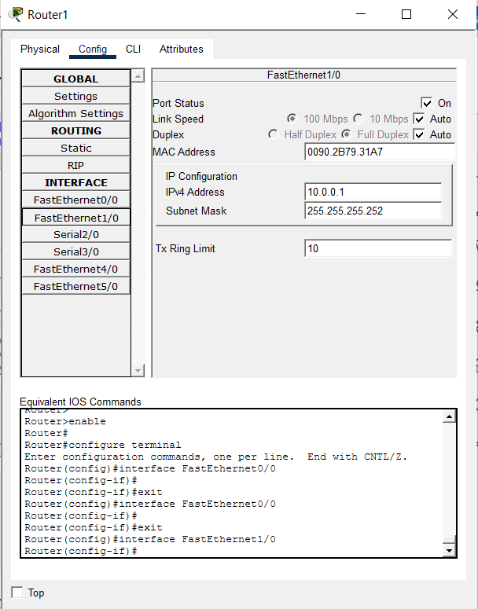

Router 2 Interfaces Configurations
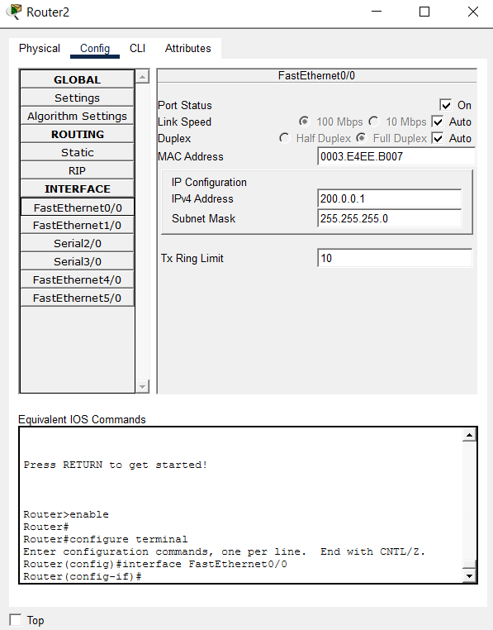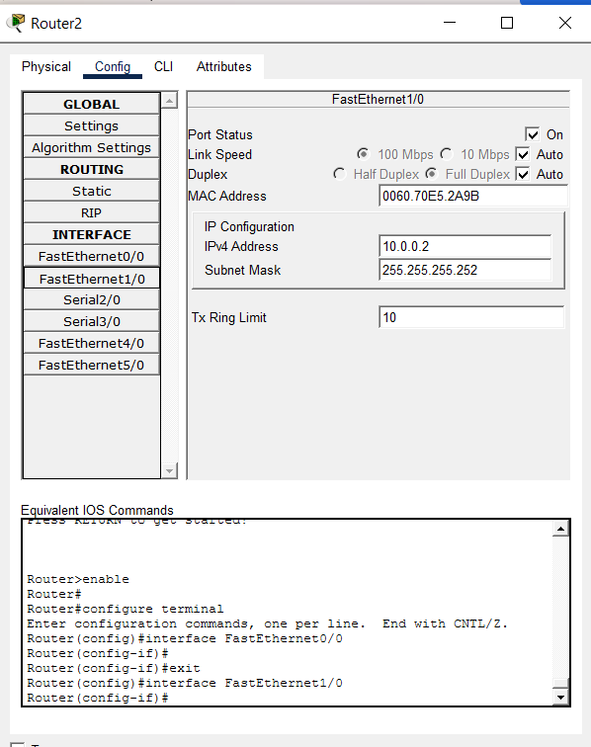

Screenshot 2 – Router 1 “Configure Router1 (Static NAT Router)”

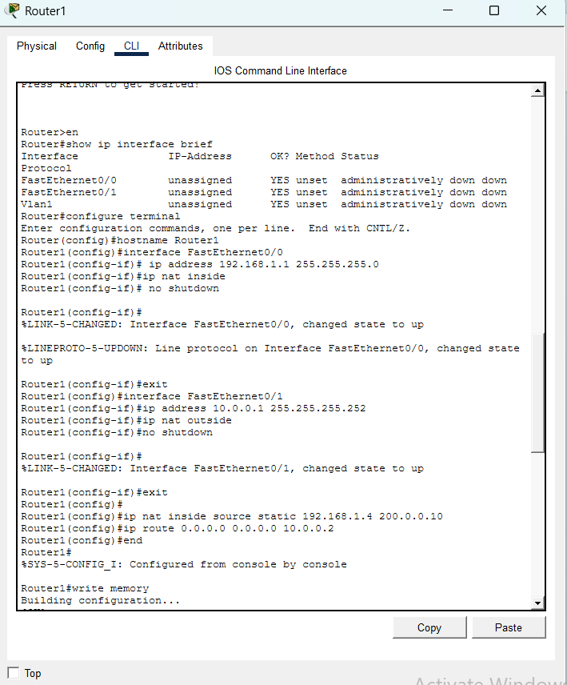

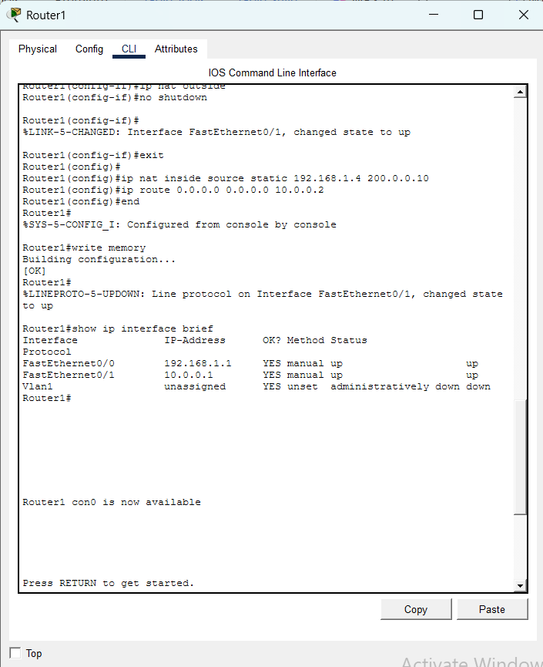

Router2 “ Configure Router2 (ISP Router)

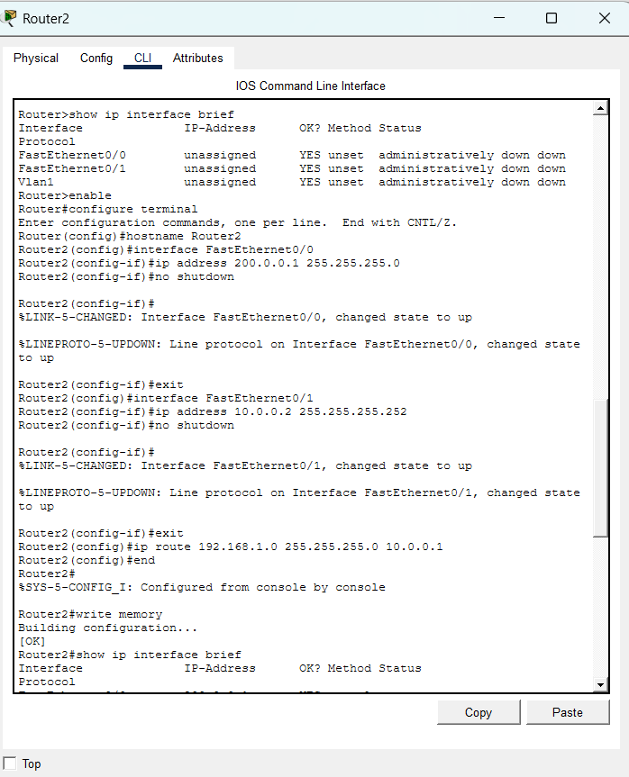

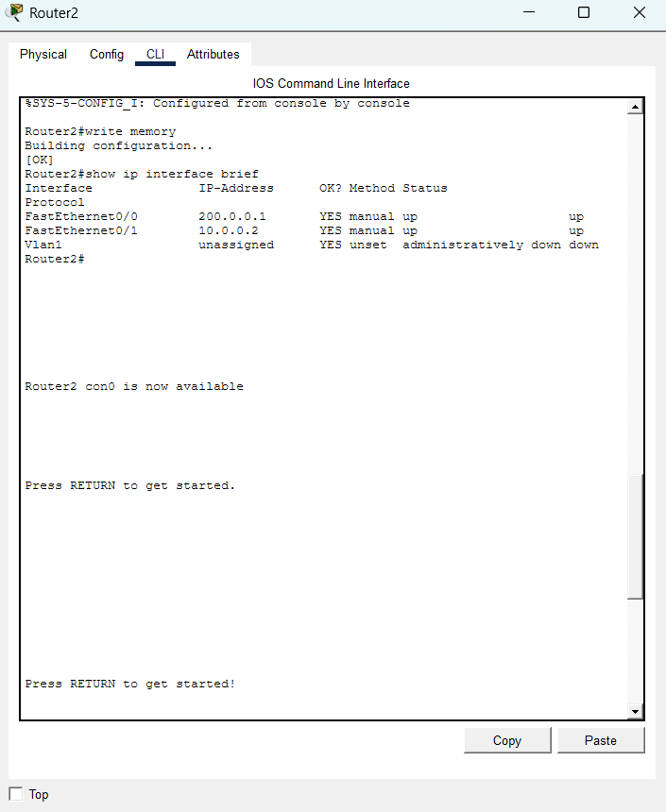
Figure 1 Figure 4: CLI output showing Router 1 interface IP assignments and NAT designation (inside/outside)
Figure 4: CLI output showing Router 1 and 2 interface IP assignments and NAT designation (inside/outside).

Screenshot 3 – Static NAT Command Configuration
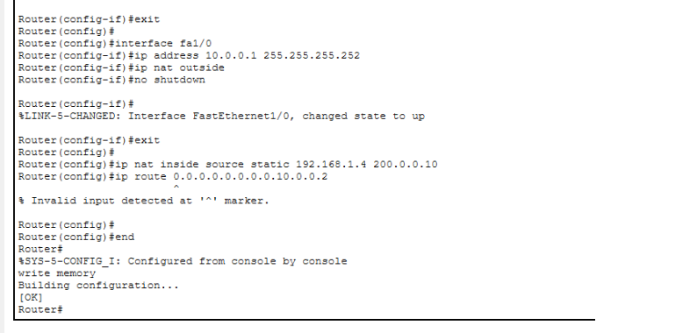
Figure 5: CLI showing the static NAT mapping command and default route configuration on Router 1.

Screenshot 4 – Ping Test: PC1 to PC0 (Private to Public)

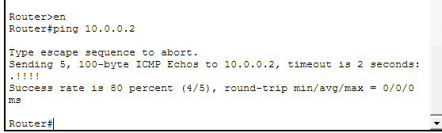

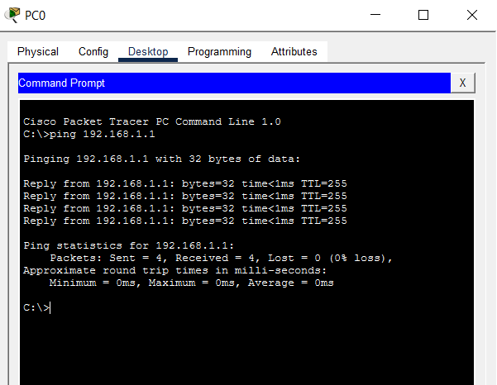

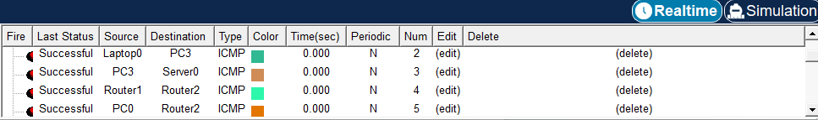

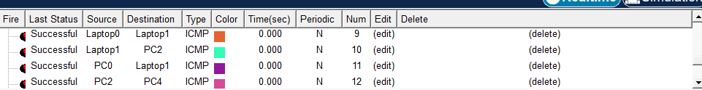

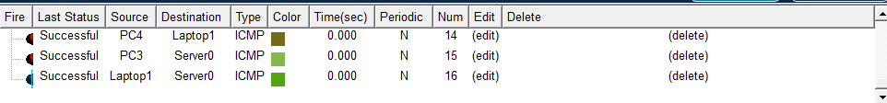
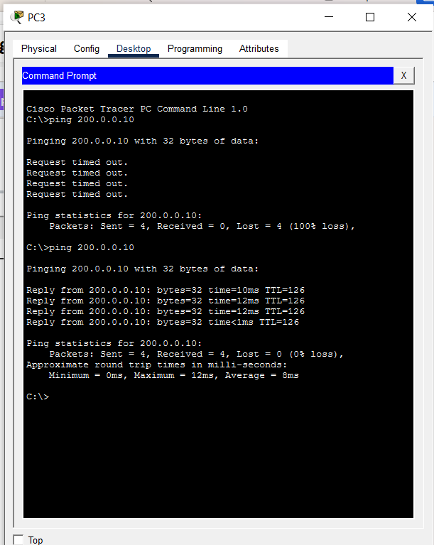
Figure 6: Successful ping from PC1 (private host) to PC0 (public host) demonstrating NAT translation is working.
Figure 6 demonstrates end-to-end connectivity between PC1 and PC0. PC1 on the private network (192.168.1.x) successfully pings PC0 on the public network. The successful ping confirms that the Static NAT configuration is translating the source address from the private IP to the mapped public IP at Router 1 before the packet reaches the public network.

Screenshot 5 – show ip nat translations
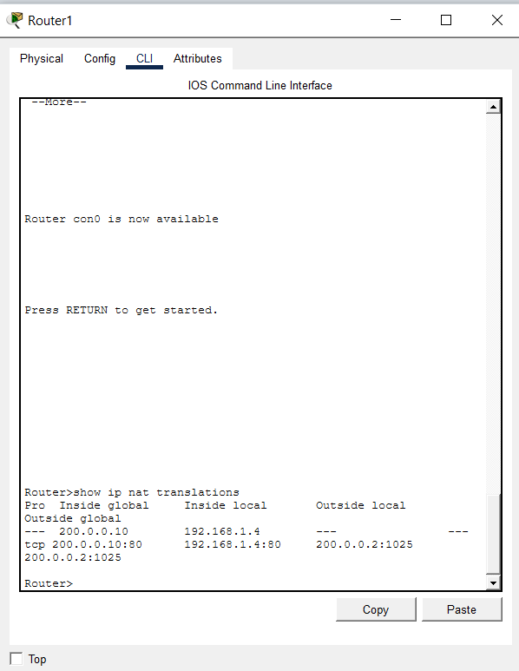
Figure 7: Output of 'show ip nat translations' command on Router 1 showing the active NAT translation entry.
Figure 7 shows the output of the 'show ip nat translations' command on Router 1. The translation table displays the static entry mapping the inside local address (PC1's private IP) to the inside global address (the assigned public IP). This confirms that NAT is actively maintaining the address mapping as configured.

Screenshot 6 – show ip nat statistics
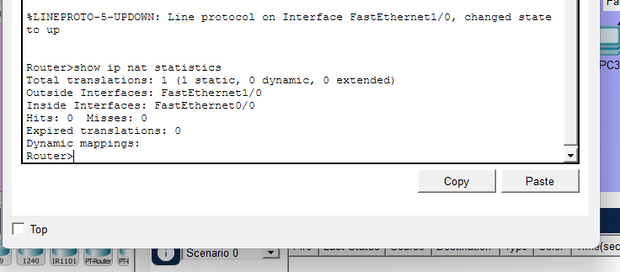
Figure 8: Output of 'show ip nat statistics' showing translation hits and misses confirming NAT activity.
Figure 8 presents the NAT statistics output, which shows the total number of active translations, the number of extended entries, and the hit/miss counters. The non-zero hit counter confirms that NAT translations are being performed successfully during the ping test.

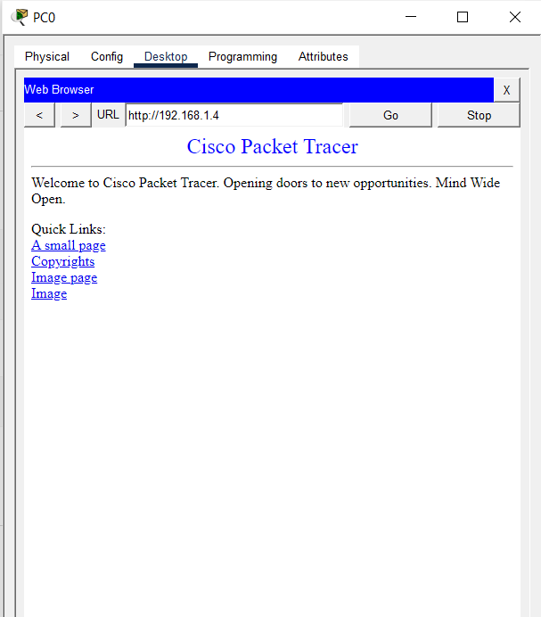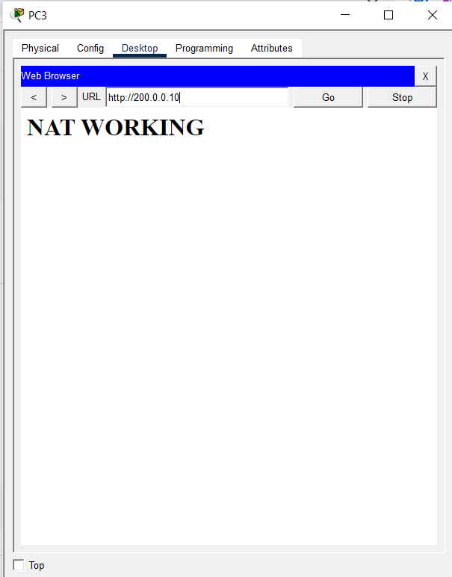
Figure 9: Successful HTTP access through Static NAT translation in Cisco Packet Tracer environment

4.2 Results Analysis
Key Results from the simulation:
- The Static NAT configuration successfully allowed the private host to communicate to a public (PC0) without having a manual step after the initial setup procedure.
- It was verified that a static mapping was permanent by executing the show ip nat translations command, which confirmed the inside local IP with an inside global IP.
- With ping tests, we observe that there was 0% packet lost, allowing us to confirm bidirectional communication through the NAT-enabled router.
- NAT statistics showed that translations were occurring and the router was performing address translation as expected.

4.3 Challenges Faced and Solutions
During implementation, the following challenges were encountered and resolved:
- Challenge: Initial ping from PC1 to PC0 was failing. Solution: It was found that the 'ip nat inside' and 'ip nat outside' commands had not been applied to the correct router interfaces. After correctly marking Fa0/0 as inside and Fa0/1 as outside, connectivity was restored.
- Challenge: The router interfaces were in administratively down state. Solution: The 'no shutdown' command was applied to all required interfaces on both routers to bring them up.
- Challenge: PC1 could not reach Router 1. Solution: The default gateway on PC1 was incorrectly configured. It was corrected to 192.168.1.1, which resolved the local connectivity issue.
- Challenge: Routing between the two routers was incomplete. Solution: A static default route was added on Router 1 pointing to Router 2's interface IP (200.0.0.1), and a return route was added on Router 2 to ensure bidirectional traffic flow.

5. Conclusion

5.1 Summary of Work
The current project showed the path to utilize and check Static Network Address Translation (Static NAT) with the tool Cisco Packet Tracer. Our working group created a network shape that contained two routers with hidden and open subnets. Specific IP addresses and interface roles were put on the Cisco routers alongside NAT rules. It has been observed that connection happened between a private computing device and a public computing device because the working group completed the setup. Successful verification was performed by the working group to ensure data flow.
Every necessary part of Static Network Address Translation was included in the work like the topology design and the setup of routers using Cisco IOS commands. Address mapping and default routing were handled while the working group checked results using 'show ip nat translations' and 'show ip nat statistics'. Experts claim that the gateway IPs 192.168.1.1 and 200.0.0.1 worked as the entry locations for the private and public networks. Static Network Address Translation remains the focus as the project finished when the system allowed the devices to communicate across different zones.

5.2 What We Learned
- Practical knowledge regarding the operation of Static NAT within the router hardware became very clear during the session. This educational institution activity allowed the group to see how Static NAT is different from Dynamic NAT and PAT. Differences between these translation methods were observed by the students throughout the exercise because the logic of each one is unique. Experts claim that understanding these variations is necessary for managing network traffic effectively. Static NAT functions with a fixed mapping that does not change, while the other types distribute addresses from a pool or use ports. Because the router hardware handles each request differently, Static NAT remains a reliable choice for servers.

- Setting up Cisco routers using the IOS CLI for interface addressing and NAT rules was a major part of the work. Proper commands were entered into the IOS CLI to ensure that the interface addressing functioned as intended within the network. It has been observed that manual configuration helps a person with a technical working position understand the core logic of the system. Static routing configuration was also completed to ensure that data reached its destination. When the NAT rules are applied correctly, the Cisco routers can direct data packets between different networks without errors because the path is clearly defined.

- Identifying the NAT inside and outside interfaces correctly is a vital step that we learned during the lab. The significance of these interface labels was understood better after the troubleshooting experience occurred. Many people believe that many errors in connectivity happen when these interfaces are swapped by mistake. Because the router needs to know which side is private and which is public, the NAT inside and outside designations must be exact. NAT inside marks the local network while NAT outside marks the global internet.

- Packet headers are modified by NAT as data moves through the network gateway. Detailed information inside the packet headers is changed by the NAT process to mask internal IP addresses for security reasons. Experts claim that the NAT translation table is the brain of the translation process because the table stores every connection. The NAT translation table keeps a record of all address mappings so that the return traffic can find the original sender. If the mapping is lost, the communication fails and the data does not reach the receiver.

- Network simulation and testing abilities were improved by using Cisco Packet Tracer software. Validation of the network setup was achieved through the Cisco Packet Tracer simulation environment during the test. It has been observed that simulation tools provide a safe way to practice before working on real hardware. Ping and show commands for verification were used to check if the translation worked. Individuals with specialized knowledge use these tools to ensure the network is stable. Because we used these commands, the success of the NAT configuration was confirmed.

5.3 Effectiveness of Implementation
This technical setup was successful in producing results. Information was sent by private hosts to public hosts through the system process of address translation without interference because the Static NAT configuration functioned with precision. Experts claim that every test ping reached its destination, while the NAT translation table showed the correct data for the static mapping that was arranged. This modeled environment showed a clear example of how NAT is utilized within large company workplace settings.

5.4 Future Improvements
- Dynamic NAT and PAT: This project grows when someone adds Dynamic NAT and Port Address Translation (PAT) because many people believe that using a single public IP for many private machines creates a realistic internet provider environment. While Dynamic NAT and Port Address Translation (PAT) are applied, the connection is shared by many machines. Experts claim that this technique allows multiple private hosts to communicate with the outside world at the same time.

- Access Control Lists (ACLs): Network safety increases when Access Control Lists (ACLs) are joined with NAT. It has been observed that Access Control Lists (ACLs) determine which internal devices have permission to enter the public network. A security boundary is established by the network administrator to stop unauthorized access. Because Access Control Lists (ACLs) regulate the data flow, the private network remains protected.

- NAT with Multiple Servers: Users configure Static NAT for several internal servers, such as those for web pages and file transfers. Each internal server is mapped to a distinct public IP address. Experts claim that this configuration demonstrates a multi-server DMZ arrangement clearly. The connection between the web server and the public IP is maintained by the routing device.

- IPv6 Transition: Investigating NAT64 and IPv6 addressing provides knowledge on how modern networks manage the shift from IPv4 to IPv6. It has been observed that NAT64 serves as a bridge during this process. Because the world requires more IP addresses, IPv6 addressing is adopted by many organizations.

- Real Hardware Deployment: Individuals install these same configurations on physical Cisco routers within an educational laboratory room. Practical knowledge is obtained by using physical Cisco routers during the training. Experts claim that encountering real-world troubleshooting scenarios helps individuals learn better than using software simulations. Because individuals work with physical Cisco routers, the understanding of the hardware becomes deep.

— End of Report —

